Table of Contents

Executive Summary 2

Motivation 2

Engineering Objectives 2

Technical Approach 2

Results 2

Summary 2

Introduction 4

General 4

Motivation 4

Engineering Objectives (or Project Design Requirements) 5

Technical Work 6

Technical Approach 6

Experimental Setup / Numerical Setup / Designs 6

Testing 13

Results 14

Discussion 15

Summary of Work 15

Future Work 16

Appendices 18

References 18

Drawings 18

Codes 20

Key Equipment 20

Sponsor Contact Information 21

# Executive Summary

## Motivation

After observing the KU mascots in action, two members of our project sent a proposal to the University of Kansas on June 23, 2023, seeking to enhance the Big Jay and Baby Jay mascots by adding Disney-like animated features and a liquid cooling garment for performer comfort. This initiative aimed to boost the mascots' appeal during key events like March Madness. However, the head mascot coach suggested creating a new mascot, Junior Jay, for the kids club of Kansas Athletics, to preserve the originality of Big and Baby Jay.

## Engineering Objectives

In response to the head mascot coach's suggestion, our team planned to integrate AI-driven facial recognition technology with mechanical systems for the Junior Jay mascot. This setup would detect and mimic the facial expressions of the person inside the mascot head in real time, translating them into movements of features like eyebrows, eyelids, and mouth via actuators and linkages. This combination of AI and mechanical engineering aims to enhance the mascot's expressiveness and ensure performer comfort during events.

## Technical Approach

To achieve our project goals, our group met weekly throughout the spring semester to develop and refine the designs for the mechanical movements needed to animate the mascot's facial features. We took a prototype and testing approach to develop Junior Jay for this project. To do so, servo motors and 3D-printed linkages were utilized and optimized for seamless integration and effective operation. During the installation phase, we performed additional redesigns to ensure the components fit well within the mascot head while maintaining comfort and wearability for the performer. This iterative design and testing process was vital for balancing functionality and user comfort.

## Results

We successfully met most of our objectives for enhancing the mascot's features, although we encountered challenges with achieving full functionality of the eyelids due to software bugs and mechanical unreliability. In the last few weeks of the project, our team intensified our efforts, focusing closely on collaboration and problem-solving to finalize the enhancements. Our result was a functioning animatronic Junior Jay with facial recognition capabilities. Despite the issues with the eyelids, our commitment in the final stages ensured that the rest of the features, including the expressive eyes and integrated cooling system, were implemented effectively. This teamwork and determination were crucial in bringing our innovative mascot enhancements to near completion, significantly elevating the mascot's functionality and appeal.

## Summary

Our project achieved substantial progress in enhancing the mascot's animated features, though some challenges, like the full functionality of the eyelids, remain. Recognizing the potential to fully realize our vision, we submitted a proposal to continue our work, aiming to deliver a completely functional mascot head. This ongoing effort will focus on resolving existing issues and refining the design to ensure it is event ready. We recommend future teams prioritize software optimization and consider further ergonomic adjustments to improve performer comfort. These steps will help in achieving a pioneering mascot presence at university events, greatly enhancing both performance and spectator experience.

# Introduction

## General

This project was sponsored by the Mechanical Engineering Department at the University of Kansas, with the primary client being the KU mascot coach. The initiative aimed to revolutionize the university's mascot program by incorporating advanced, expressive features into the Big Jay and Baby Jay mascots. Inspired by the intricate articulation of iconic characters such as Disney's Mickey and Minnie Mouse, the enhancements were intended to include a range of animated facial expressions and integrated cooling systems to ensure performer comfort during performances, especially in warm conditions. This effort aligns with the university's broader goals of enhancing school spirit and audience engagement during athletic events and other university functions. The project's strategic objective was to significantly elevate the visibility and interactive capability of the mascots, thereby enriching the fan experience and potentially increasing student and community involvement with Kansas Athletics.

## Motivation

The motivation for this project stemmed from a desire to enhance the interactive capabilities and overall appeal of the University of Kansas mascots, Big Jay and Baby Jay, as expressed by the client, the KU mascot coach. The primary requirements outlined by the client included the ability for the mascots to display a wide range of dynamic, real-time facial expressions, like those seen in professionally animated characters. This enhancement was aimed at fostering a more lively and engaging presence at university events, thereby deepening the emotional connection between the mascots and the audience.

Additionally, the client emphasized the need for improved comfort for the mascot performers, particularly during the intense heat often experienced during early season football games and other outdoor activities. This led to the requirement for integrating advanced cooling technologies within the mascot suits, specifically through the development of a Liquid Cooling Garment system that could maintain a comfortable temperature for the performers over extended periods.

These enhancements were expected to boost the morale and performance of the mascot team and to serve as a pioneering model for other universities looking to upgrade their mascot programs. The overarching goal was to create mascots that are not only emblematic of KU spirit but also stand out on a national level during high-visibility events such as March Madness, thereby attracting more attention and potentially increasing enrollment and fan support. This project was also seen as a strategic move to innovate within the realm of collegiate mascots, pushing the boundaries of mascot interaction and performance.

## Engineering Objectives (or Project Design Requirements)

The engineering objectives for this project were defined to directly address the customer requirements and ensure a high level of performance and innovation in the mascot enhancements. The primary design requirements included:

1. Facial Expression Animation: The mascots needed to be capable of displaying a variety of facial expressions that mimic human emotions. This required the development of a sophisticated mechanical system within the mascot heads, utilizing servo motors, sensors, and 3D-printed components to animate features like the eyebrows, eyelids, and mouth in real-time.
2. Facial Recognition Integration: To achieve real-time mimicry of the performer’s expressions, an AI-driven facial recognition system was required. This system would interpret the performer's facial expressions captured via an internal camera and translate them into mechanical movements, ensuring that the mascot's external expressions reflect those of the performer inside.
3. Cooling System Implementation: Given the physical exertion and heat exposure during performances, integrating a Liquid Cooling Garment (LCG) was essential. This system needed to be seamlessly incorporated into the mascot suit, providing efficient heat exchange without adding significant weight or restricting the performer's movements.
4. Durability and Comfort: All enhancements had to be designed with durability and comfort in mind. The mechanical components and cooling systems needed to withstand the rigors of performances and be easy to maintain. Moreover, the overall design had to ensure that the weight distribution and ergonomics of the mascot suit did not compromise the performer’s comfort or mobility.
5. Ease of Use and Maintenance: The systems developed for the mascots needed to be user-friendly, allowing quick adjustments and repairs if necessary. This was crucial for ensuring that mascot handlers could manage the technology effectively during events without requiring specialized knowledge.

These engineering objectives were crafted to create a mascot experience that was not only more engaging and enjoyable for audiences but also more manageable and comfortable for performers, setting a new standard for mascot design in collegiate sports.

# Technical Work

## Technical Approach

Our team took a general engineering design approach with this project. Throughout the project, our team met in weekly meetings to discuss and design Junior Jay. Phase 1 included concept design where our team defined the problem statement, product design specification, engineering objectives, and concepts to satisfy those engineering objectives. Phase 2 involved embodiment design where Junior Jay was broken down into three sections: mechanical, electrical, and software. Mechanical systems included design of the beak, eyebrows, and eyelids. Electrical systems included development of the main CPU being the Raspberry Pi, power, power block, and camera. Software included facial recognition to input facial expression signals and output a signal to the mechanical system. With these three sections, modeling, sizing of parts, prototyping, and testing occurred. Our team designed, iterated, and tested Junior Jay was fully functioning. Lastly, phase 3 included detail design where all the sections of Junior Jay were finalized installed into the head as a final product.

## Experimental Setup / Numerical Setup / Designs

**Beak**

In the design of the mechanical mechanisms for our animatronic Jayhawk head, a primary focus was on ensuring robustness and minimizing weight. One critical component was the beak actuation mechanism, which required careful consideration due to the forces involved, particularly gravity. The beak assembly (figure 1) consisted of an aluminum frame inserted into it to provide rigidity and a point for the servo motors to drive the beak. To achieve reliable operation, we selected servo motors capable of delivering high torque. Specifically, we used servos rated for 45 kg·cm of torque, suitable for the demands of our application.

The beak itself has a mass of 0.36 kg (Figure 3), and the aluminum frame increased the mass to 0.7kg. Through a simple finger-balance test, we determined its center of gravity to be approximately 230 mm (9 inches) from the motor's pivot point. Given this configuration, the required torque to move the beak was calculated as follows:

Torque τ is given by $τ=r·F$, where 𝑟 is the radius (distance from pivot), and 𝐹 is the force due to gravity acting on the mass.

Converting the mass of the beak into weight using the acceleration due to gravity (g=9.81 m/s^2):

$$F=m·g=0.7 kg·9.81 \frac{m}{s^{2}}=6.87 N$$

The lever arm 𝑟 is 0.230 m (230 mm). Thus, the required torque is:

$$τ=0.230 m · 6.87 N=1.58 N·m$$

Each servo, providing 4.41 Nm (45 kg·cm), and with two servos employed, yielded a total available torque of 8.82 Nm (90 kg·cm). This is significantly more than the required 1.58 N $·$ m, ensuring that the servos can operate the beak with high reliability and responsiveness, even under additional load, external forces, or in the event one motor fails.

**

Figure 1 (Left): Complete Beak Assembly

Figure 2 (Right): Aluminum Frame CAD Model

Figure 3: Jaw mass (without Al Frame)

**Eyebrows**

To enable the mascot to dynamically express emotions, precise control over the eyebrows was essential. Given the design constraints that the eyebrow actuation mechanisms must remain concealed, the servos were hidden inside the head. Initially, a simpler design featuring a single rotation point at the center of each eyebrow was considered.This would have only required one servo motor for each eyebrow, but ultimately, we settled on a slightly more complicated design that used two servos and incorporated the eyebrow as a three-bar linkage (figure 4). The benefit to this design was that there were now two pivot locations, enabling the eyebrow to raise and lower itself without changing the angle it was oriented at. The servos were conveniently mounted to the eyelid Al frame. These servos had shaft extensions that protruded through the forehead by way of two small holes. The arms were fastened into these extended shafts, which had press-fit threaded inserts and a star pattern connection interface (figure 5) to ensure the arms would not slip. One arm kept its pivot at a fixed distance, while the other had a slider cutout which allowed for its pivot to translate back and forth. This combined setup allowed for free rotation and translation eyebrow. The arms are completely hidden behind the eyebrow and colored the same as the eyebrow for camouflage and redundancy.

The installation and calibration of the eyebrows, essential for achieving precise expression angles, involved attaching the arms at the same angle the servo shaft was set to. To facilitate this process, a Python script was developed which could directly control each eyebrow servo via a simple slider interface through a serial connection with the Raspberry Pi. This allowed for precise adjustment and easy selection of the optimal angles for expressing different emotions. After fine-tuning the servos to the desired positions for each emotion using a practical approach, the angles were recorded and integrated into the master script for consistent application.

Figure 4 (Left): Complete eyebrow assembly, (top: front view, bottom: back view)

Figure 5 (Right): Star pattern connection utilized for servo extension and links

**Eyelids**

To improve the animatronics' eyelid functionality, a new eye design was developed using SLA 3D printing, creating a smooth surface that allows for uninterrupted eyelid movement (figure 6). This process involved vacuum forming a PETG plastic sheet over the 3D printed model to ensure minimal material friction and enhance performance. For precise eyelid motion, a compact timing belt system was chosen instead of gears or chains due to its reliability and quiet operation, similar to those used in 3D printers. The frame was designed to support the eyebrow mechanics while providing enough space for the eyelid material to spool without increasing in diameter. Initially, a DC motor was considered for this system, but its torque, size, and control limitations led to the selection of a continuous servo motor, which offers sufficient torque and simpler control. To compensate for the servo's slower speed, a gear system was incorporated to increase the speed of the eyelid movement while maintaining the necessary torque for smooth operation. Unlike a normal servo, the continuous servo has no positional feedback. To work around this, two limit switches were added so that a the belt system would trip one when the eye was fully open, and the other when fully closed, thus shutting off the motors.

Figure 6 (Left): Vacuum forming PETG plastic eye

Figure 7 (Left): Complete eyelid assembly

Figure 8 (Right): Eyelid CAD model

**Electrical System**

The electrical system composed of 50,000 mAh battery pack specifically chosen for a 2hr. lifetime (or that of a typical basketball game), its three USB type A and C ports, and its 5-20V capacity. This battery choice was driven by the aforementioned 45 kg·cm servos we selected required 9V power to achieve our torque target. Two HUSB238 power delivery breakouts configured to draw 5V and 9V respectively were connected the USB ports on the battery. The Raspberry Pi was directly connected to the third port. In this configuration, all the servos requiring 5V (eyelid and eyebrow servos) were powered separately from the 9V servos (beak servos). Miscellaneous components such as the eyelid limit switches, fans, camera, and LED indicator panel were to be powered by the Raspberry Pi.

There were two key considerations when designing this system. This system contains approximately fifty loose wires, and it quickly became apparent that wire management was crucial for easy maintenance, visibility inside the head, and ensuring the integrity of the sensitive wiring. All wires were strategically routed around the internal structure of the head (figure 9). Wires were systematically braided and grouped by sub-system, labeled, and secured to prevent obstruction of vision, reduce tangling risks, and simplify maintenance procedures. A Raspberry Pi GPIO pin extension board with screw clamps was used and gave much needed easy accessibility when pulling and plugging wires. A power bus was designed and implemented that handled the distribution of power to all motors in a convenient location. Since these electrical components would be operating very close to a human’s face, safety was also a top priority. Initial testing done on the 9V beak servos under high load produced worrying results on the multimeter. In some cases, the current draw of an individual servo could spike to well over 1A. To prepare for dangerous current spikes like this, two 1Ω power resistors in series were added to the 9V rail on the power bus to dissipate any excess current as heat. An emergency safety switch was also added to shut the 9V motors off.

These efforts not only ensured the operational safety of the animatronic but also enhanced the overall user experience by maintaining clear visibility and ease of use.

Figure 9. Wires were braided and routed for easy plug-in

Figure 10. Electronics (left to right): Raspberry Pi 4B, 8gb RAM; Custom 5V/9V Power Bus; HUSB Power Delivery Breakout; Arducam USB Camera (Low Light, 160° Wide Angle)

Figure 11: Electrical System Schematic

**Software**

A distinctive aspect of this project that underscores its innovative potential, particularly in terms of intellectual property, is the integration of facial detection technology. This software enables the animatronic to interact dynamically with its environment, recognizing and responding to human faces in real-time. This capability not only sets our animatronic apart from traditional models but also opens avenues for patentability due to its unique application in an animatronic context.

The software algorithm is actually a single “master” python script running on the Raspberry Pi, which handles everything from the capturing of video frames, detection of faces, prediction of a facial expression, and sending of signal to the motors to adjust servo angles to mimic the detected expression.

Early in the development process, it was decided that due to computational limitations of the Raspberry Pi and to avoid jittery mechanical movements, the software would predict discrete emotions and control the motors in set configurations (figure 12). This approach was chosen over a design that would mimic every nuanced movement of the wearer, prioritizing smooth and stable operation of the mascot.

Thus, the facial detection was naturally split up into different sections based on the mechanical sub-system that it would control. For control of the eyes and mouth, first open-source computer vision libraries were used to extract the coordinates of the facial landmarks (eyes, mouth, nose, chin, etc.). Expressions were then classified by measuring the distance between a select few coordinates and comparing them to some empirically determined ratio. This method implemented in the final master script uses the *dlib* model, although Google's *MediaPipe* model was also considered.

The movement of the eyebrows, arguably the most important mechanical sub-system in dynamic emotion display, was more intricate. Two approaches were tested for detecting the wearer's expressions as "neutral," "angry," "happy," "surprised," or "sad," based on the distance between the inner brow points. The first approach uses a similar approach to the mouth and eye detection, this time using the *MediaPipe* or *dlib* library to extract the eyebrow facial landmark coordinates and calculate certain distances, like the distance between the eyebrows and the aspect ratio.

The second, more effective approach involves an image classification model. A convolutional neural network (CNN), trained on the *FER-2013* facial emotion dataset, classifies facial expressions (figure 13). The master script uses this model to predict emotions from the webcam stream. The model achieves over 75% accuracy on the validation dataset (figure 14), with even better performance observed in practical use, potentially a result of the *FER-2013* dataset's well-known problem with inconsistent labeling.

Whatever the approach, signals to the motor servos were sent to the designated pins using the *pigpio* library.

In order to ensure the program could run as close to real-time as possible, steps were taken to reduce the computational load. One simple approach used was to limit the number of frames processed. Several different frame rates were tested, and ultimately 5 fps was chosen as a nice balance between computational low cost and quick enough updates. The images were also converted to greyscale before processing, which is what the model was trained on and also happens to be more computationally efficient. The model was run using Google’s *TensorFlow. Lite* library, which is purpose built for running models on lighter hardware.

Challenges in detecting faces within the dark, close-up environment inside the mascot's head, even with the use of a low-light, wide-angle camera, hindered the successful demonstration of the internal camera functionality. Efforts to improve face detection under these conditions included enhancing illumination and artificially padding the frame borders to create the illusion of a more distant face. For our demonstration purposes, the camera was positioned outside the head. Future work is required to fully achieve the project's initial objectives under these specific conditions.

As a reminder, all final and test code for the model training process, pre-trained models, can be found in the project GitHub page linked in the appendix.

Figure 12: Junior Jay’s five discrete emotions

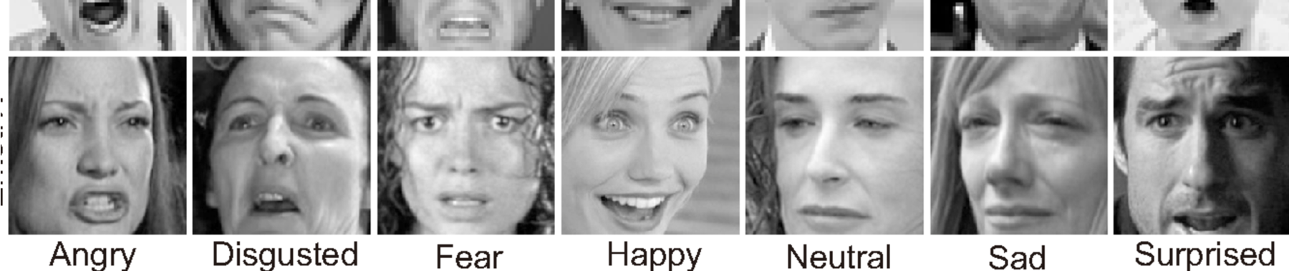

Figure 13: FER-2013 dataset used for training the emotion detection model (fear and disgust emotion classes were not used)

Figure 14: Training accuracy and loss for CNN model trained on FER-2013 dataset

## Testing

To assess Junior Jay, we evaluated the performance of each mechanical system against the following criteria:

1. Feature of mechanical system moves in an aesthetically pleasing way
2. Feature of mechanical system moves in a timing comparable to the real-life movement of human features
3. System can operate without fault for 5 minutes

Each system was tested, compared, and iterated until these criteria were met.

In terms of the electrical systems, testing involved troubleshooting all connections to ensure they were permanently connected and maintained control over the mechanical systems for 5 minutes. Also, cooling fans were subjectively measured per use of the user over 5 minutes of testing. 5-minute intervals were repeated for each system until the whole mascot head could simultaneously run together for 5 minutes.

Much testing was done to ensure that the software was able to accurately and consistently predict emotions of a variety of subjects. Model class predictions were plotted to a GUI window on a monitor (figure 15) to easily see exactly how confident the model was in a certain emotion at a certain instance. A key tool employed was manual biasing of certain emotions. For example, the model tended to incorrectly predict “sad” as “angry”, but never the opposite. The solution for this was to artificially bias the program to as to give less weight to predicting “angry”. This allowed sadness to be predicted with much more frequency.

Figure 15: Master script running. Emotion detection (teal) with breakdown of class predictions (yellow), eye state (blue), and mouth state (red) are plotted on a GUI window to give visual feedback for testing purposes.

## Results

The beak, eyebrow, and eyelid mechanical systems were prototyped and iterated upon until its movement looked natural, quick, and could run longer than 5 minutes. The beak could complete one open and close cycle in 0.5 seconds. The eyebrow system could reach various positions in under 0.25 seconds, and could achieve 5 different predefined facial expressions; neutral, happy, mad, sad, surprised. The eyelids were never demonstrated successfully with the whole integrated head, but they were successfully able to complete an open and close cycle in 1.5 seconds during independent testing. The camera and facial recognition software detected various user facial expressions with ease and output a signal to the mechanical systems within 1 second. Furthermore, the camera and facial recognition software could run for longer than 5 minutes. Lastly, the fans were subjectively concluded as adequate over the testing period of 5 minutes.

Figure 16: Final product with the team (from right to left): Jake Eggleston, Josh Ryan, Luke Jansen, Scott Klein, and Bao Ngyuen

# Discussion

## Summary of Work

Overall, a Junior Jay mascot was created with expressive capabilities. Junior Jay is equipped with a Raspberry Pi board powered by a 5-volt battery pack, and an external digital camera that acts as an input. Another 5-volt battery pack and 9-volt battery pack, attached to a custom power breakout board, power the rest of the systems of the mascot head. The jaw is equipped with two 45-kilogram servo motors, bracket mounts, and an aluminum frame to move the jaw. The eyelids include an aluminum frame and rod system that spools eyelid fabric by means of a servo motor, belts, and switches. The eyes are made of vacuum formed plastic with layers of film to provide a one-way mirror window. The eyebrows are equipped with two 7 kg micro servo motors each attached to the eyelid frame, links, and fabric covered 3D printed eyebrows. Lastly, 4 micro fans are scattered throughout the helmet to provide cooling.

The culmination of these mechanical systems along with a Raspberry Pi Board, camera, and batteries allows for a mascot head that mirrors multiple facial expressions of the camera user. The eyebrows and jaw of junior jaw worked seamlessly and realistically, with a battery life of about 4 hours. The facial recognition along with the camera were able to detect and interpret facial expressions of most camera users with a response time of 1 second. The operation of the mascot head was comfortable and was adequately cooled. The one-way mirror window design of the eye’s allowed for proper vision and use. Batteries were stored in a backpack worn by the mascot user, which also allowed Junior Jay to be mobile. After testing Junior Jay, the final operating time was close to 3 hours without any issues. While most of the mascot head worked, the eyelids had a short life cycle along with dysfunctional code and were not powered on for the final exposition.

In short, Junior Jay worked well and met all engineering objectives. Junior Jay performed facial expression animation for various human emotions, involved facial recognition of camera users, included a cooling system, was durable and comfortable enough to operate for several hours, and could be easily operated.

## Future Work

While the project has made significant strides in enhancing the functionality and appeal of the university mascots, there remains scope for further development to fully realize the envisioned goals. Future work could focus on several areas to refine and expand the project's achievements:

1. Refinement of Mechanical Systems: Further refinement of the mechanical systems controlling facial expressions is essential. Continuous testing and iteration could lead to more fluid and natural movements, reducing any mechanical lag or stiffness currently present.
2. Advanced AI and Machine Learning: Implementing more sophisticated AI algorithms and machine learning techniques, such as training on a larger dataset or a custom dataset built to our specific needs, could enhance the accuracy and responsiveness of the facial recognition system. Also, work can be done to give more nuanced expressions prediction rather than the simpler discrete expression approach used. This would ensure a more precise and seamless translation of the performer’s expressions to the mascot.
3. Enhanced Cooling Technologies: Although the current cooling system provides basic relief, exploring advanced technologies like phase change materials or more efficient heat exchange mechanisms could offer better temperature regulation, increasing comfort during longer performances or in more extreme weather.
4. Integration of Interactive Technologies: Adding interactive technologies such as voice modulation and responsive sound systems could make the mascots even more engaging. For instance, allowing the mascots to respond vocally to crowd interactions or integrate sound effects linked to their movements could greatly enhance audience interaction.
5. Sustainability and Materials Science: Investigating more sustainable materials and construction techniques that maintain durability while reducing weight could improve the ergonomics and environmental impact of the mascot costumes.
6. Extended Wearability Studies: Conducting extended wearability studies to gather data on the performer's comfort and suit ergonomics over longer periods can provide insights into necessary adjustments and improvements.
7. Scalability and Transferability: Finally, considering how these enhancements can be standardized and transferred to other mascot programs could broaden the impact of the project. Developing a modular system that can be customized and adapted to different mascots could make these advancements more accessible to other institutions.
8. Foolproof electrical safety measures: A mechanical cover should be added to cover the power bus to protect against accidental contact and reduce the risk of short circuits. Additionally, wiring may be optimally routed inside the head wall to minimize exposure and vulnerability. Safety devices such as fuses, and micro-circuit breakers will be incorporated to prevent electrical overloads and potential hazards.

These areas of future work would not only address the remaining challenges but also push the boundaries of what is possible in mascot design and performance, potentially setting new industry standards.

# Appendices

## References

"Bird Anatomy for Animators." Journal of Animation Studies.

US Patent CN201780082251.0A, " Social robot with environmental control features."

US Patent 11592659, “Optical viewfinder for costume heads.”

AnimationResources.org. "Bird Animation Tutorials."

Williams, Richard. "The Animator's Survival Kit."

International Animation Society (IAS). "Standards for Non-Human Character Animation."

## Drawings

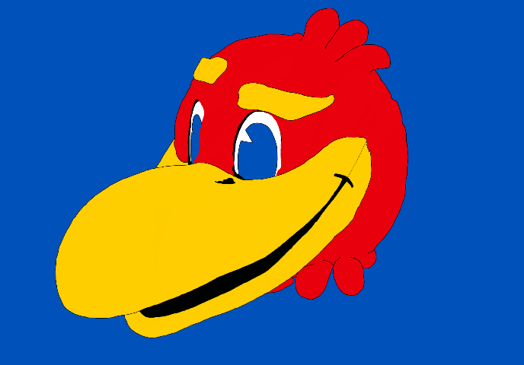

Figure A1. Head concept 1

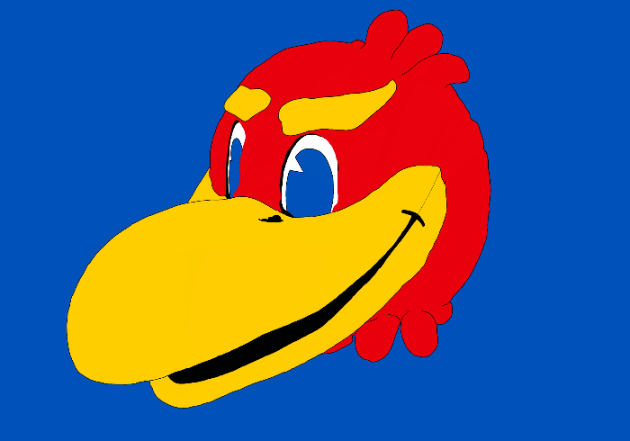

Figure A2. Head concept 2

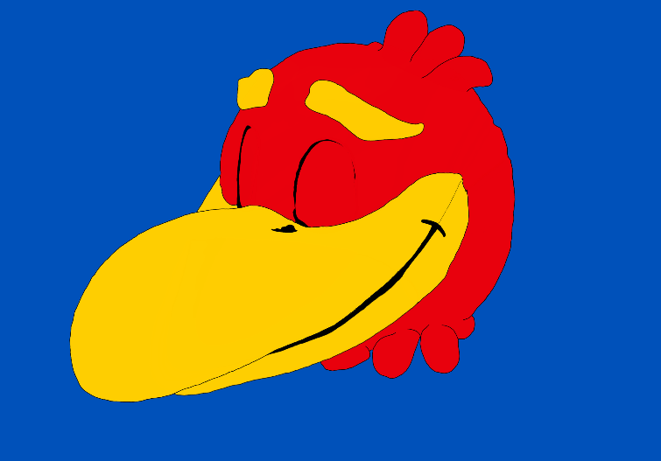

Figure A3. Head concept 3

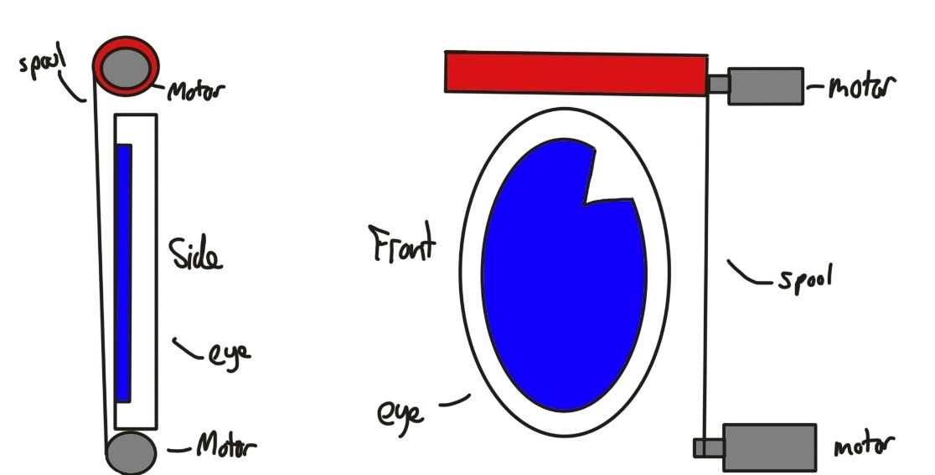

Figure A4. Eye concept (up)

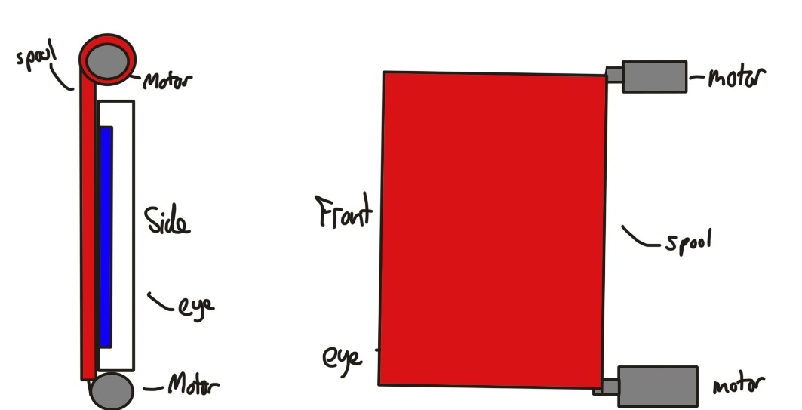

Figure A5. Eye concept (down)

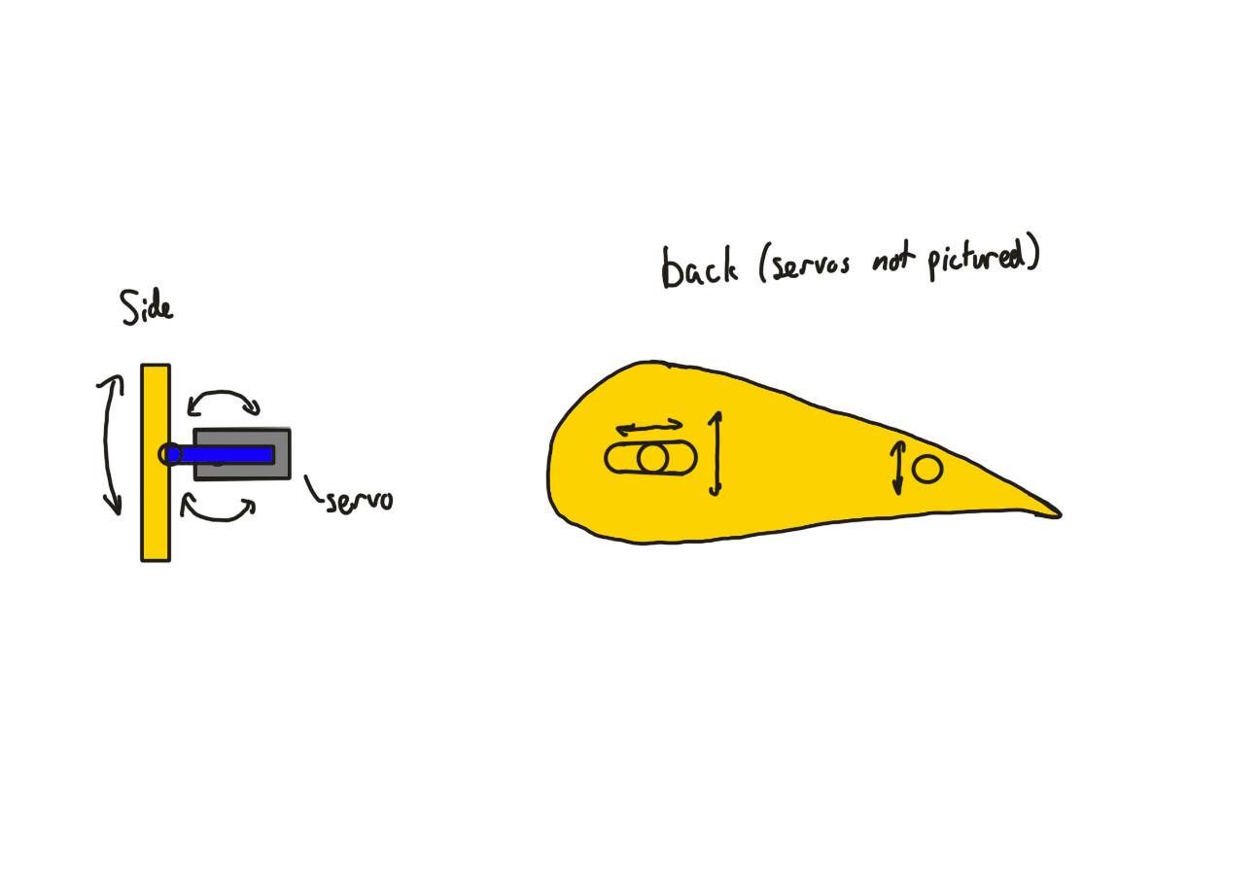

Figure A6. Eyebrow concept

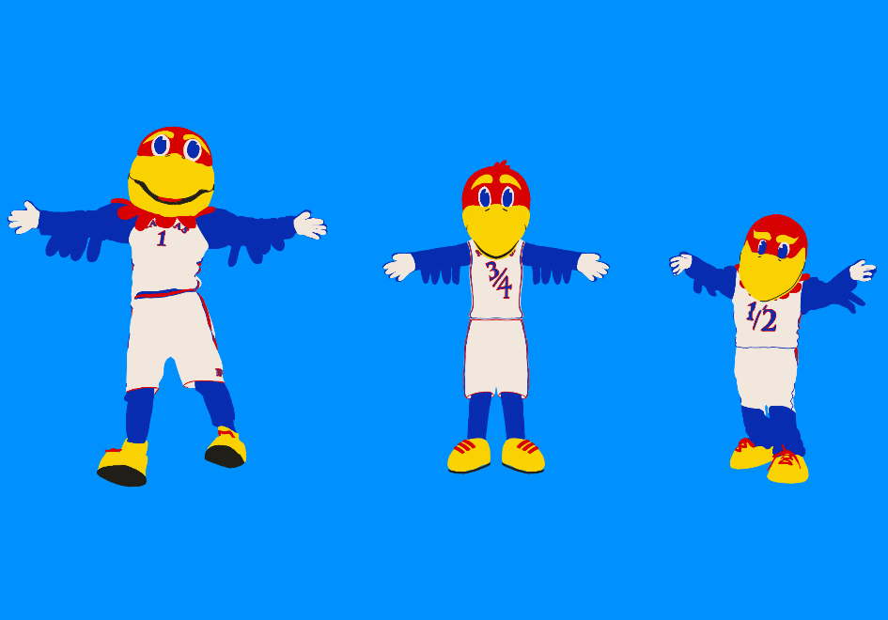

Figure A7. Full mascot suit concept (Big Jay, Junior Jay, Baby Jay)

## Code

All code used for this project can be conveniently found on the following GitHub repository: <https://github.com/lujan002/Animatronic-Mascot-Suit>

## Key Equipment

List the ***major equipment*** with supplier and part numbers – only things that were unique and critical

|  |  |  |
| --- | --- | --- |
| **Item** | **Vendor** | **Part Number** |
| Arducam USB Camera (Low Light, 160° Wide Angle) | Amazon | B07ZS75KZR |
| 45 kg High Torque Servo | Amazon | B0C69BXL6V |
| Injora 7kg digital servo | Amazon | B0BLBMVYCW |
| Raspberry Pi 4 Model B - 8GB RAM | Adafruit | 4564 |
| Pisoo 65W Power Bank | Amazon | B0C5D1JR2K |

## Sponsor Contact Information

KU Athletics Mascot Coach: Brian Carpenter - [bcarpenter@ku.edu](mailto:bcarpenter@ku.edu)

KU School of Engineering: Dr. Pourladian - [bamdadpourladian@ku.edu](mailto:bamdadpourladian@ku.edu)